How Fulham Spent and Performed in 2024/25
- 25% of the squad collected 51% of the team’s total salary.
- 37% of the salary was spent on forwards, well above the league’s 29% average.
- The highest earner was goalkeeper Bernd Leno (9%).
- 0.59 points earned per million spent.
- Rebalance wages and invest in development.
- Brentford, Nottingham Forest, Brighton and Bournemouth are models of success.
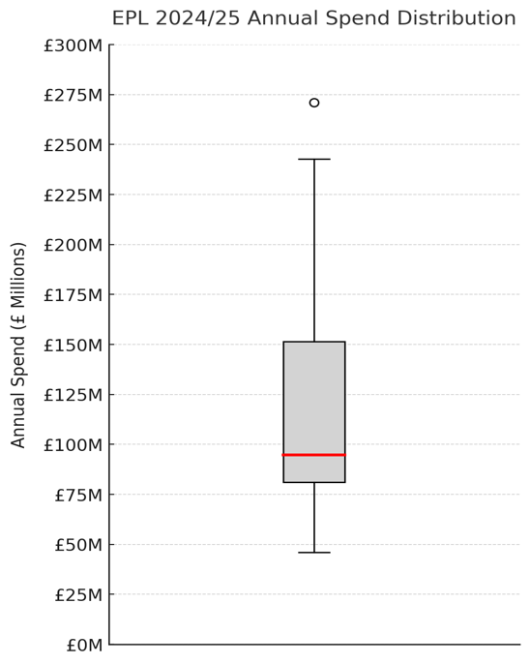
The 2024/25 Premier League season showcased a contrast between financial power and spending efficiency. Liverpool topped the table with 83 points and justified their £173 million wage bill, while Arsenal and Manchester City filled out the remaining spots in the top 3, and both spent over £220 million.
Whilst these are impressive feats, Fulham’s ability to perform is limited to their “mid-table” salary. It is therefore important to compare them to similar teams. Brentford impressed as the league’s most efficient side, earning 55 points on just £55 million. While spending slightly less than Everton (£96 million) and Crystal Palace (£94 million), Fulham managed an extra 9 and 2 points more, respectively. Fulham finished 10th with 54 points from a £92 million spend. Brighton finished just above in 8th, yet managed to do so with £9 million less. Nottingham Forest spent most of the year in the top 4 and finished 7th, despite their £85 million spend.

Team |  | Difference in League Position | Difference in Annual Spend
Nottingham Forest | 3 |  | 6596810
Brighton | 2 |  | 8656136
Brentford | 1 |  | 36160304
Bournemouth | -1 |  | 18394286
Crystal Palace | -2 |  | -1884806
Everton | -3 |  | -4048839
Leicester City | -8 |  | 4013932
Southampton | -10 |  | 16614193
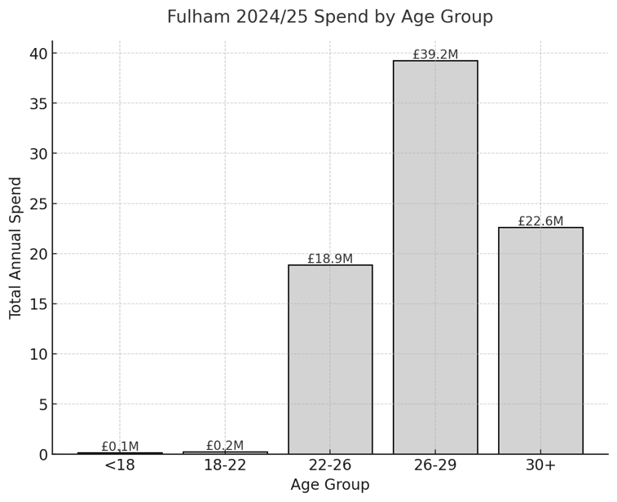
Fulham’s 2024/25 salary structure is top-heavy, with a few senior players taking a large share of the annual spend. The squad’s median salary is £3.18m, and Bernd Leno leads on £8.26m (9% of total spend). The bottom five players make up less than 2%, adding to this imbalance. Fulham also invest heavily in forwards (37%), more than the league average (29%). Overall, a quarter of the squad earns 51% of the team’s total salary.
When comparing to some close counterparts, it’s evident that Nottingham Forest and Bournemouth spread their wages more evenly, while Brighton and Brentford are the most balanced, relying on younger, cheaper squads. On the other hand, Southampton, Everton, Crystal Palace and Leicester are more top-heavy than Fulham, with one or two players taking over 10% of total spend. This shows Fulham’s structure is imbalanced, but not as extreme as some other teams. Importantly, these teams finished below Fulham, while the more balanced, youth-focused models seen at Brighton and Brentford outperformed Fulham over the course of the season.

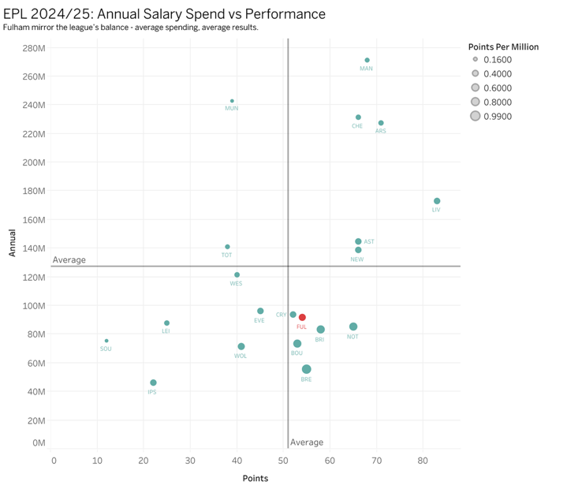
Fulham’s 2024/25 campaign reflects a club that spends reasonably economically, earning 0.59 points per million spent, which places them 5th in the league for efficiency. Comparing them to their more refined competition paints a slightly different picture. They sit amongst a competitive mid-table cluster, slightly ahead of Crystal Palace (0.55) and well above Everton (0.47), but behind several close counterparts who turned similar budgets into stronger returns. Brentford set the benchmark with an exceptional 0.99 points per million, while Nottingham Forest (0.76), Bournemouth (0.72) and Brighton (0.70) also outperformed Fulham despite operating with comparable or even smaller budgets. These clubs represent realistic models for Fulham to strive for as they compete in the same financial bracket, yet achieve more with less. While giants such as Manchester City, Arsenal and Chelsea can afford to prioritise results over efficiency, Fulham should look to emulate clubs that thrive through smart recruitment and player development, identifying undervalued talent, strengthening squad depth without inflating costs. Further research into the models used by clubs like Brentford, Nottingham Forest, Bournemouth and Brighton is necessary.
Fulham’s forwards produced 1.86 goals and assists per million spent (GA/M), a mid-table return that sits well below the benchmark set by Brentford (4.97) and Wolves (3.24), and behind several close counterparts such as Brighton (2.60), Nottingham Forest (2.46), Bournemouth (2.13) and Crystal Palace (2.04). They remain ahead of Everton (0.84), Leicester (1.47) and Southampton (0.66), but the gap to the best-performing mid-table clubs highlights clear room for improvement. Rodrigo Muniz delivered exceptional value with 18.9 GA/M, one of the league’s standouts and outperforming attackers at Nottingham Forest (Elanga, 10.71 GA/M), Palace (Mateta, 5.04 GA/M), Brighton (Adingra, 5.04 GA/M) and Bournemouth (Ouattara, 4.95 GA/M). Brentford, once again, are a model of success with 3 forwards in the top 10, including Kevin Schade’s league-high of 20.47 GA/M.
At Fulham, Alex Iwobi and Harry Wilson provided steady mid-range returns, but high-earning veterans, like Raúl Jiménez and Willian, underperformed relative to cost. These two take 14% of the annual spend, yet combined for an output of less than 2.5 GA/M. Given that 37% of Fulham’s total wage bill is invested in forwards, their output should be higher, but once again, it’s an imbalance of spending that has meant they trail the most efficient attacking units in the league.

Overall, Fulham’s 2024/25 season reflects a club that has achieved respectable stability but still operates below its potential in terms of spending efficiency. The analysis highlights an overreliance on a small group of high-earning veterans and an imbalance in wage allocation, particularly toward attacking and goalkeeping positions, while several players delivered limited returns relative to cost. To progress, Fulham should look to rebalance their squad structure, investing more evenly across positions and prioritising players who can contribute consistently. Strengthening squad depth and continuing to develop younger, long-term assets would help build a more sustainable and productive roster. Further research should focus on the systems in place at Brentford, Nottingham Forest, Bournemouth and Brighton.
It is important to note that this analysis excludes transfer fees and loan expenditures, focusing instead on total player spend (including wages and related costs). This approach highlights trends that are repeatable year to year, but it also limits the ability to fully capture investment value or short-term strategic spending. Future work incorporating transfer costs, bonuses, and player market value could provide a more complete picture of Fulham’s financial performance and return on investment.

